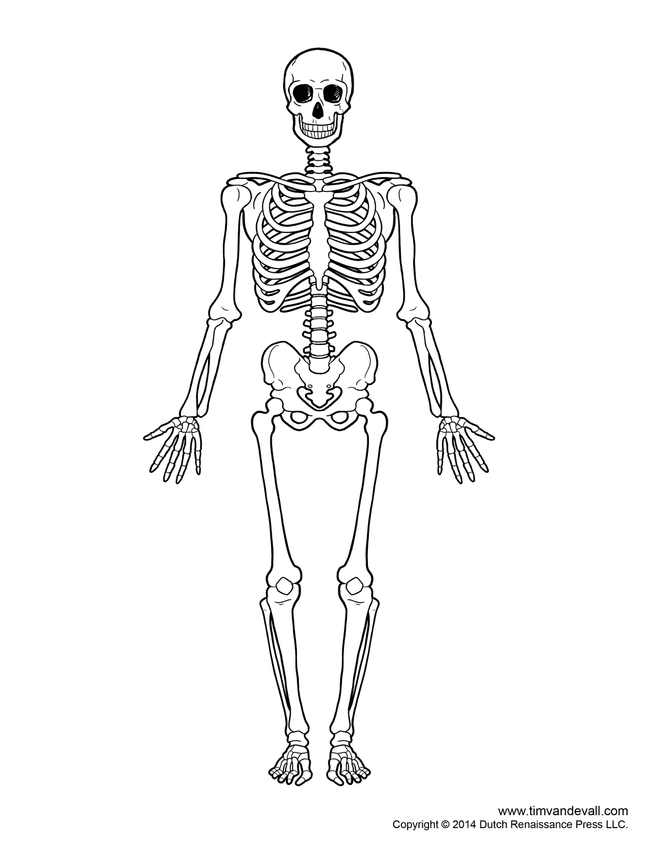

Immediate Treatment; Unresponsive but does have pulse and is breathing

Open Wound/Bleeding to Right Side of Neck

Frostbite to Right Foot (notify after patient assessment)

Internal Bleeding Abdomen

Impaled Sight Rod In back/ribs

Dislocated Right Shoulder

Closed Fracture Right Elbow

Closed Fracture Right Forearm

Fractured Index, Middle, and Ring Fingers

Open Cut/Wound Right Thigh

Open Fracture Right Femur



**List of Injuries to be Treated**

* Open/Bleeding Wound Right Thigh
* Internal Bleeding Abdomen
* Open Wound Neck
* Impaled Sight Rod in Back
* Closed Fracture Right Forearm
* Dislocated Right Shoulder
* Closed Fracture Right Elbow
* Closed Fracture Right Index, Middle, and Ring Fingers
* Open Fracture Right Femur
* Shock (envelope to tell team after treating frostbite)
* Each critical skill identified with an asterisk (*) or a double asterisk (**) shall be clearly verbalized by the team as it is being conducted.
* After initially stating what BP-DOC- Bleeding, Pain, Deformities, Open Wounds, Crepitus stands for, the team may simply state BP-DOC when making their checks. Teams may use the acronym “CSM” after first stating what CSM means, circulation, sensation, and motor function, when checking.

**Initial Assessment**

**Procedures: Critical Skills**

|  |  |  |
| --- | --- | --- |
| 1. SCENE SIZE UP | **□**  **□** | **A. Observe area to ensure safety  **B. Call for help |
| 2. MECHANISM  OF INJURY | **□**  **□**  **□** | **A. Determine causes of injury, if possible  **B. Triage: **Immediate**, Delayed, Minor or Deceased.  **C. Ask patient (if conscious) what happened |
| 3. INITIAL  ASSESSMENT | **□**  **□**  **□** | **A. Verbalize general impression of the patient(s)  **B. Determine responsiveness/level of consciousness (AVPU) Alert, Verbal, Painful, Unresponsive  **C. Determine chief complaint/apparent life threat |
| 4. ASSESS AIRWAY AND BREATHING | **□**  **□**  **□** | A. Correctly execute head-tilt/chin-lift or jaw thrust maneuver, depending on the presence of cervical spine (neck) injuries  B. Look for absence of breathing (no chest rise and fall) or gasping, which are not considered adequate (within 10 seconds)  C. If present, treat sucking chest wound |
| 5. ASSESS FOR CIRCULATION | **□**  **□**  **□** | A. Check for presence of a carotid pulse (5-10 seconds  B. If present, control life threatening bleeding  C. Start treatment for all other life-threatening injuries/conditions |

** Patient is IMMEDIATE based on symptoms. He/she is unresponsive BUT does have a pulse and is breathing

** 4 life threatening injuries will be found & should be treated during the initial assessment. The order in which these are found and treated does not matter.

**TRANSPORTATION IS DELAYED (*state once life-threatening conditions have been treated and team is ready to transport*)**

***After Treatment of life-threatening injuries is complete and team is ready to transport, **Transportation is DELAYED (stated by judges)** at which point the team will assess and treat all remaining injuries until transport is ready

**PATIENT ASSESSMENT**

**Procedures: Critical Skills**

|  |  |  |  |
| --- | --- | --- | --- |
| 1. HEAD | □  □  □  □  □  □  □ | **A.  **B.  **C.  **D.  **E.  **F.  **G. | Check head for BP-DOC: Bleeding, Pain, Deformities, Open wounds, Crepitus  Check and touch the scalp  Check the face  Check the ears for bleeding or clear fluids  Check the eyes for any discoloration, unequal pupils, reaction to light, foreign objects and bleeding  Check the nose for any bleeding or drainage  Check the mouth for loose or broken teeth, foreign objects, swelling or injury of tongue, unusual breath odor and discoloration |
| 2. NECK | □  □ | **A.  **B. | Check the neck  Inspect for medical ID |
| 3. CHEST | □  □  □ | **A.  **B.  **C. | Check chest area  Feel chest for equal breathing movement on both sides  Feel chest for inward movement in the rib areas during inhalations |
| 4. ABDOMEN | □ | **A. | Check abdomen (stomach) |
| 5. PELVIS | □  □ | **A.  **B. | Check pelvis Inspect pelvis for injury by touch (Visually inspect and verbally state inspection of crotch and buttocks areas) |
| 6. LEGS | L  □  □  □  □  □ | R  □  □  □  □  □ | **A. Check each leg  B. Inspect legs for injury by touch  C. Unresponsive: Check legs for paralysis (pinch inner side of leg on calf)  **D. Responsive: Check legs for motion; places hand on bottom of each foot and states “Can you push against my hand?”  **E. Check for medical ID bracelet |
| 7. ARMS | L  □  □  □  □  □ | R  □  □  □  □  □ | **A. Check each arm  B. Inspect arms for injury by touch  C. Unresponsive: Check arms for paralysis (pinch inner side of wrist)  **D. Responsive: Check arms for motion (in a conscious patient; team places fingers in each hand of patient and states “Can you squeeze my fingers?”  **E. Check for medical ID bracelet |

**Open Wound to Right Thigh**

**LIFE-THREATENING BLEEDING**

|  |  |  |
| --- | --- | --- |
| 1. DIRECT PRESSURE AND ELEVATION | □  □  □  □  □ | *A. Apply direct pressure with a gloved hand (if dressing is not readily available)  *B. Apply a dressing to wound (cover entire wound) and continue to apply direct pressure  *C. Elevate the extremity except when spinal injury exists  **D. Bleeding has been controlled  *E. If controlled, bandage dressing in place |
| 2. IF NOTIFIED THAT BLEEDING IS NOT CONTROLLED, APPLY TOURIQUET | □ | A. Apply as per tourniquet skill sheet |

**TOURNIQUET REQUIRED (Not controlled with direct pressure or elevation)**

|  |  |  |
| --- | --- | --- |
| 1. DETERMINE NEED OR USING TOURNIQUET | □  □ | If these conditions are met, a tourniquet may be the only alternative:  A. Direct pressure has not been successful in stopping bleeding  B. Elevation of wound above heart has not been successful in stopping of bleeding |
| 2. SELECT  APPROPRIATE MATERIALS | □ | A. Select a band that will be between 1-4 inches in width and can be wrapped six or eight layers deep for improvised tourniquet or select factory tourniquet. |
| 3. APPLY TOURNIQUET | □  □  □  □ | Factory Tourniquet  A. Wrap band around the extremity proximal to the wound (one 2–3 inches above but not on a joint)  Improvised Tourniquet  B. Apply a bandage around the extremity proximal to the wound (one inch above but not on a joint) and tie a half knot in the bandage  C. Place a stick or pencil on top of the knot and tie the ends of the bandage over the stick in a square knot  D. Twist the stick until the bleeding is controlled, secure the stick in position |
| 4. APPLY PRESSURE WITH TOURNIQUET | □  □ | A. Do not cover the tourniquet with bandaging material  **B. Notify other medical personnel caring for the patient |
| 5. MARK PATIENT APPROPRIATELY | □ | A. Mark a piece of tape on the patient’s forehead “TQ” and Record time applied |
| 6. REASSESS | □ | **A. Assess level of consciousness (AVPU), respiratory status, |

**Internal Bleeding to Abdomen**

**Abdominal Injury**

*1. Place on back with legs flexed at the knees (for closed or open wounds)

**Internal Bleeding**

**1. Monitor breathing and pulse

**2. Keep patient still. Reassure patient and keep calm

**3. Loosen restrictive clothing

**4. Be alert if patient vomits

**5. Nothing by mouth

**6. Report possibility of internal bleeding as soon as EMS personnel arrive on

**Open Neck Wound/Bleeding**

**LIFE-THREATENING BLEEDING**

**Open Neck Wound (Serious or Life Threatening)**

*1. Gloved hand over wound

*2. Occlusive dressing over wound- 2 inches larger than wound site, use tape to seal the dressing on all sides

3. Gauze dressing over occlusive

4. Place roller gauze beside site and wrap around figure 8 under opposite arm

|  |  |  |
| --- | --- | --- |
| 1. DIRECT PRESSURE AND ELEVATION | □  □  □  □  □ | *A. Apply direct pressure with a gloved hand (if dressing is not readily available)  *B. Apply a dressing to wound (cover entire wound) and continue to apply direct pressure  *C. Elevate the extremity except when spinal injury exists  **D. Bleeding has been controlled  *E. If controlled, bandage dressing in place |

**External Bleeding**

To Control: 1st: direct pressure

2nd: elevation & direct pressure

**Bleeding is Controlled with Direct Pressure**

**Impaled Sight Rod in Back**

**DRESSINGS AND BANDAGING – OPEN WOUNDS**

|  |  |  |
| --- | --- | --- |
| PROCEDURES CRITICAL SKILLS 1. EMERGENCY CARE FOR AN OPEN WOUND | □  □  □  □ | *A. Control bleeding  *B. Prevent further contamination  *C. Bandage dressing in place after bleeding has been controlled  *D. Keep patient lying still |
| 2. APPLY DRESSING | □  □  □  □ | A. Use sterile dressing  B. Cover entire wound  C. Control bleeding  D. Do not remove dressing |
| 3. APPLY BANDAGE | □  □  □  □  □ | A. Do not bandage too tightly.  B. Do not bandage too loosely.  C. Cover all edges of dressing.  D. Do not cover tips of fingers and toes unless they are injured.  E. Bandage from the bottom of the limb to the top (distal to proximal) if applicable. |

**Impaled Objects**

*1. Do not remove

2. Expose wound

3. Control bleeding

4. Stabilize with a bulky dressing; crisscross the layers

5. Secure in place

*6. Check for exit wound (treat when found)

7. Immobilize affected area

**Open Fracture of Right Femur (Right Thigh)**

**SPLINTING (RIGID OR SOFT) PELVIC GIRDLE, THIGH, KNEE AND LOWER LEG**

|  |  |  |
| --- | --- | --- |
| PROCEDURES CRITICAL SKILLS 1. DETERMINE NEED FOR SPLINTING | □  □ | **A. Assess for:  ▪ Pain  ▪ Swelling  ▪ Deformity  B. Determine if splinting is warranted |
| 2. APPLY MANUAL STABILIZATION | □ | A. Support affected limb and limit movement ▪ Do not attempt to reduce dislocations |
| 3. SELECT  APPROPRIATE SPLINT | □  □ | A. Select appropriate splinting method depending on position of extremity and materials available  B. Select appropriate padding material |
| 4. PREPARE FOR SPLINTING | □  □  □  □  □ | A. Remove or cut away clothing as needed  **B. Assess distal circulation, sensation, and motor function  C. Cover any open wounds with sterile dressing and bandage  D. Measure splint  E. Pad around splint for patient comfort |

**Closed Fracture Right Elbow**

**SPLINTING (RIGID) UPPER EXTREMITY FRACTURES AND DISLOCATIONS**

|  |  |  |
| --- | --- | --- |
| 1. CARE FOR FRACTURE | □ | **A. Check for distal circulation, sensation, and motor function  ▪ Do not attempt to reduce dislocations (if applies) |
| 2. IMMOBILIZING FRACTURE | □  □  □  □  □  □  □ | A. Selection of appropriate rigid splint of proper length  B. Support affected limb and limit movement  C. Apply appropriate padded rigid splint against injured extremity  D. Place appropriate roller bandage in hand to ensure the position of function  E. Secure splint to patient with roller bandage, handkerchiefs, cravats, or cloth strips  F. Apply wrap distal to proximal  **G. Reassess distal circulation, sensation, and motor function |

**ELBOW (STRAIGHT POSITION)**

Follow Procedures No. 1 and No. 2 above

**Closed Fracture of Right Index, Middle, and Ring Fingers**

**SPLINTING (RIGID) UPPER EXTREMITY FRACTURES AND DISLOCATIONS**

|  |  |  |
| --- | --- | --- |
| PROCEDURES CRITICAL SKILLS 1. CARE FOR FRACTURE | □ | **A. Check for distal circulation, sensation, and motor function  ▪ Do not attempt to reduce dislocations (if applies) |
| 2. IMMOBILIZING FRACTURE | □  □  □  □  □  □  □ | A. Selection of appropriate rigid splint of proper length  B. Support affected limb and limit movement  C. Apply appropriate padded rigid splint against injured extremity  D. Place appropriate roller bandage in hand to ensure the position of function  E. Secure splint to patient with roller bandage, handkerchiefs, cravats, or cloth strips  F. Apply wrap distal to proximal  **G. Reassess distal circulation, sensation, and motor function |

**FINGER/FINGERS**

Immobilize Fracture

1. Tape injured finger to an adjacent uninjured finger; or

2. Tape injured finger to a tongue depressor, aluminum splint, or pen and pencil

3. Secure with sling and swathe

**Dislocated Right Shoulder**

**SPLINTING (RIGID) UPPER EXTREMITY FRACTURES AND DISLOCATIONS**

|  |  |  |
| --- | --- | --- |
| PROCEDURES CRITICAL SKILLS 1. CARE FOR FRACTURE | □ | **A. Check for distal circulation, sensation, and motor function  ▪ Do not attempt to reduce dislocations (if applies) |
| 2. IMMOBILIZING FRACTURE | □  □  □  □  □  □  □ | A. Selection of appropriate rigid splint of proper length  B. Support affected limb and limit movement  C. Apply appropriate padded rigid splint against injured extremity  D. Place appropriate roller bandage in hand to ensure the position of function  E. Secure splint to patient with roller bandage, handkerchiefs, cravats, or cloth strips  F. Apply wrap distal to proximal  **G. Reassess distal circulation, sensation, and motor function |
| 3. SECURING WITH SLING | □  □  □  □  □  □  □  □ | A. Place sling over chest and under arm  B. Hold or stabilize arm  C. Triangle should extend behind elbow on injured side  D. Pull sling around neck and tie-on uninjured side  E. Pad at the neck (except when C-Collar is present)  F. Secure excess material at elbow  G. Fingertips should be exposed  **H. Reassess distal circulation, sensation, and motor function |
| 4. SECURING SLING WITH SWATHE | □  □  □ | A. Use triangle cravat or factory swathe  B. Swathe is tied around chest and injured arm  **C. Reassess distal circulation, sensation, and motor function |

**SHOULDER BLADE**

Support and limit movement of affected area Follow Procedures No. 1, No. 3 and No. 4 above

**Closed Fracture Right Forearm**

**SPLINTING UPPER EXTREMITY/LOWER EXTREMITY FRACTURES (AIR SPLINT)**

|  |  |  |
| --- | --- | --- |
| PROCEDURES CRITICAL SKILLS 1. CARE FOR FRACTURE | □ | **A. Assess distal circulation, sensation, and motor  function(fingers/toes) |
| 2. IMMOBILIZE FRACTURE | □  □  □  □  □  □ | A. Grasp above and below the injury site  B. Maintain support  C. Properly apply air splint  D. Splint should be relatively free of wrinkles  E. Inflate splint to point that slight dent can be made  **F. Reassess distal circulation, sensation, and motor  function (fingers/toes) |
| 3. MONITOR AIR- INFLATED SPLINT | □  □  □  □ | **A. Periodically check for increase or decrease in pressure  **B. Monitor pressure in splint with fingertip  C. Make sure desired pressure is maintained  **D. Reassess distal circulation, sensation, and motor function (fingers/toes) |

**SHOCK**

**(NOTIFIED AFTER COMPLETING PATIENT ASSESSMENT BY ENVELOPE #1)**

|  |  |  |
| --- | --- | --- |
| 1. CHECK FOR SIGNS AND SYMPTOMS OF SHOCK | □  □  □ | **A. Check restlessness; anxiety; altered mental status; increased heart rate; normal to slightly low blood pressure; mildly  increased breathing rate: pale (or bluish) skin (in victim with dark skin examine inside of mouth and nailbeds for bluish coloration).  **B. Check for cool, moist skin; sluggish pupils; and nausea and vomiting.  **C. Check for weakness |
| 2. TREATMENT | □  □  □  □  □  □  □  □ | A. Ensure the ABCs are properly supported.  B. Control external bleeding.  C. Keep the patient in a supine position.  **D. Calm and reassure the patient and maintain a normal body temperature.  E. Cover with blanket to prevent loss of body heat and place a blanket under the patient. (Do not try to place blanket under patient with possible spinal injuries)  F. Continue to monitor and support ABCs  G. Do not give the patient anything by mouth. Do not give any fluids or food and be alert for vomiting.  **H. Monitor the patient’s ABCs at least every five minutes.  **I. Reassure and calm the patient |

*AFTER ALL INJURIES HAVE BEEN TREATED BY THE TEAM (AT LEAST THE ONES THEY PLAN ON TREATING) AND THE BACK SURFACES HAVE BEEN CHECKED FOR DOTS AND GIVE THE TEAM ENVELOPE #2 INSTRUCTING THEM TO PERFORM 2 SETS OF 2 PERSON CPR

**TWO-RESCUER CPR WITH AED (NO SPINAL INJURY - MANIKIN ONLY)**

|  |  |  |
| --- | --- | --- |
| PROCEDURES CRITICAL SKILLS 1. RESCUER ESTABLISH UNRESPONSIVENESS | □  □  □  □  □ | A. Tap or gently shake shoulders  **B. “Are you OK?”  C. Determine unconsciousness without compromising cervical spine (neck) injury  **D. “Call for help”  **E. “Get AED” (**Note**: If AED is used, follow local protocol) |
| 2. RESCUER MONITOR PATIENT FOR BREATHING | □ | A. Look for absence of breathing (no chest rise and fall) or gasping breaths, which are not considered adequate (within 10 seconds) |
| 3. RESCUER CHECK FOR CAROTID PULSE | □  □  □  □ | A. Correctly locate the carotid pulse - on the side of the rescuer, locate the patient’s windpipe with your index and middle fingers and slide your fingers in the groove between the windpipe and the muscle in the neck  B. Check for presence of carotid pulse for 5 to 10 Seconds  **C. Absence of pulse  D. Immediately starts CPR if no pulse |
| 4. RESCUER POSITION FOR COMPRESSIONS | □  □  □ | A. Locate the compression point on the breastbone between the nipples  B. Place the heel of one hand on the compression point and the other hand on top of the first so hands are parallel.  C. Do not intentionally rest fingers on the chest. Keep heel of your hand on chest during and between compressions. |
| 5. RESCUER DELIVER CARDIAC COMPRESSION | □  □  □  □ | A. Give 30 compressions  B. Compressions are at the rate of 100 to 120 per minute  C. Down stroke for compression must be on or through compression line  D. Return to baseline on upstroke of compression |
| 6. RESCUER ESTABLISH AIRWAY | □  □ | A. Kneel at the patient’s side near the head  B. Correctly execute head-tilt/chin-lift maneuver |

* AFTER 2-SETS OF 2-PERSON CPR GIVE ENVELOPE #3

*** TEAM SHOULD NOW PREPARE THE PATIENT FOR TRANSPORTATION

**TWO-PERSON LOG ROLL**

|  |  |  |
| --- | --- | --- |
| **PROCEDURES CRITICAL SKILLS 1. STABILIZE HEAD** | **□** | **\*A. Stabilize the head and neck** |
| **2. PREPARING THE PATIENT** | **□**  **□** | **A. When placing patient on board place board parallel to the patient**  **B. Kneel at the patient’s shoulders opposite the board (if used) leaving room to roll the patient toward knees Raise the patient’s arm, if not injured (the one closer to the rescuer) above the patient’s head** |
| **3. PREPARING THE RESCUER** | **□**  **□** | **A. Grasp the patient at the shoulder and pelvis area**  **B. Give instructions to bystander, if used to support** |
| **4. ROLLING THE PATIENT** | **□**  **□**  **□**  **□**  **□** | **A. While stabilizing the head, roll the patient toward the rescuer by pulling steadily and evenly at the shoulder and pelvis areas**  **B. The head and neck should remain on the same plane as the torso**  **C. Maintain stability by holding patient with one hand and placing board (if used) with other**  **D. Roll the body as a unit onto the board (if used) (board may be slanted or flat)**  **E. Place the arm alongside the body** |

**\*\*\* ROLL AWAY FROM IMPALED SITE ROD (ROLL AWAY FROM LEFT SIDE**